Virtual meeting checklist and risk assessment

If you’re planning an online activity with young members you need to:
• Complete this checklist and risk assessment.
• Consider risks and benefits of different online tools and check their terms and conditions and age restrictions.
• Ask your local commissioner for help if needed.
• Read our information on safe online guiding.
• Check you have enough adults to run the meeting by reading our adult to child ratios information.
• Make sure you have consent forms from all participants.
• Make sure all members’ details are up-to-date on GO and that you have the right photo permissions.
• Check that you have the appropriate level of safe space training to run the meeting.
• Make sure you are familiar with relevant policies and procedures, such as digital safeguarding, and risk assessment.
• Consider brushing up on your digital skills so you’re confident to react to any issues that arise in the meeting.
• Check that volunteers have a current disclosure check (Disclosure Barring Service (DBS), Protecting Vulnerable Groups Scheme
(PVG), Access NI or international equivalent).
• Have at least one unit leader (or someone working towards their leadership qualification).

This template can be used as a basis for your risk assessment. But, keep in mind that each unit is unique, and so risk may vary depending on the unit, age of the girls, what online tools you’re using and the type of activities you have planned. This list is not exhaustive, but is designed as a starting point to support volunteers. You can complete one risk assessment to cover your virtual meetings for the term.

Use this box to give the information requested from the checklist above
Membership numbers of your team.  Highlight Y to confirm they have a current disclosure check | 1. | Y/N | 3. | Y/N
 | 2. | Y/N | 4. | Y/N
Membership numbers of volunteers with
A Safe Space Level 3.
Membership numbers of volunteers with,
or working towards, their leadership qualification.

Date that you checked all members’ details are up to date on GO (including photo permissions).

Risk assessment: Event or activity

Using this template, you should risk assess activities and events in line with Girlguiding’s Risk Assessment Policy. Using the information on the website and this cover page, you should be able to identify effective risk management strategies and tasks
to ensure that activities run safely and effectively.
For more information or support with risk assessments, please speak to your local commissioner.
• Hazards are anything that has the potential to cause harm (eg cars, trip hazards, exposed electrical wires, theft, etc.)
• Risk is the likelihood of something happening, combined with the severity of the harm that could be caused by one or
more hazards
Risk management is a dynamic cycle that needs to be repeated in order to effectively manage risk. The frequency of reassessment will depend on activity, and new risks could occur that have not previously been assessed. In this instance, a dynamic risk assessment is required.
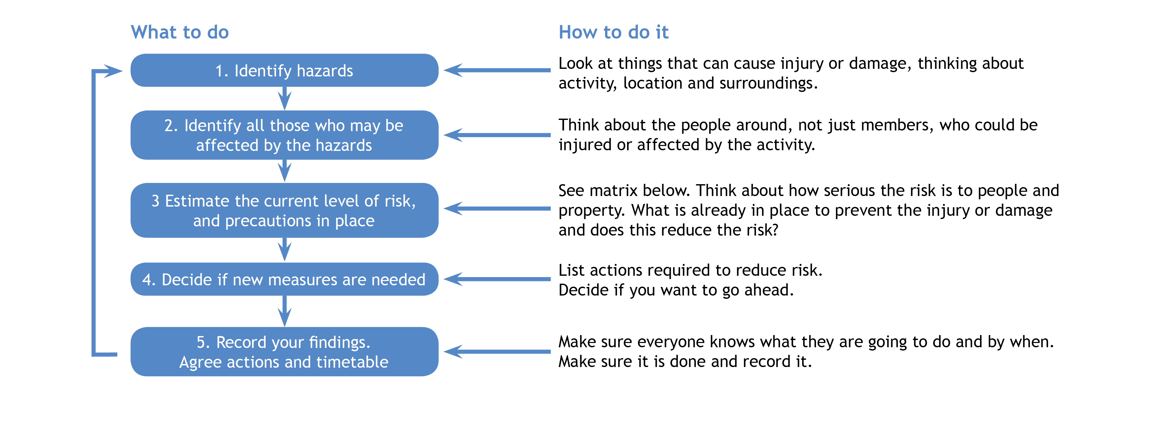

Severity  Likelihood | Slight harm  (Superficial injuries, minor cuts and bruises) | Harmful  (Minor fractures, ill health leading to minor disability) | Extremely harmful  (Multiple injuries, major fractures, fatalities)
Unlikely  (Rarely happens) | Low risk | Low risk | Medium risk
Likely  (Often happens) | Low risk | Medium risk | High risk
Very likely  (Nearly always happens) | Medium risk | High risk | High risk

Meeting information and risk assessment approval
Name of unit: |  |  | Date:
Leader in charge: | Total attending: | Adults:¹ | Girls/young women:
Up-to-date contact details held for all members: Y/N
Decision: once all the actions are carried out can you eliminate or safely manage the risk of harm to ensure you can safely go ahead with this event/activity (i.e. have degree of challenge, harm and risk whilst being confident the control measures in place will keep girls safe). |  |  | Y/N
If you answered ‘no’ to the above decision question, please explain why:

Risk assessment completed by: |  |  | Role:
Has the risk assessment been shared with the leadership team? |  |  | Y/N
Risk assessment due for review: |  |  | Date:

¹ Adults refers to adult volunteers who are part of the event/activity delivery team
Hazards  What could cause harm or damage? | Who or what is at risk of being affected and how? | What are you  already doing?  How have you reduced the  risk already? | Likelihood of risk occurring  (L/M/H) | Severity  of risk  (L/M/H) | Are further controls necessary?  What else needs to happen to reduce the risk to an acceptable level? | Action by:  name/date
Uninvited or unknown people attending meetings. | All meeting participants at risk of being exposed to inappropriate or offensive material,  or a data breach. | - Use a new password for every meeting.  - End the meeting immediately and make all parents/carers aware if an uninvited or unknown person attends a meeting.  - Use the waiting room and ‘room lock’ functions if they are available. | M | M | - Make sure all members have their video on and their name,  so they are identifiable.  - Ask members to use a first name only so they’re not easily identifiable to any uninvited attendees.  - Tell parents/carers not to share a meeting link or password with others, including other parents/carers.
Inappropriate location for meeting (young members or volunteers). | All meeting participants at  risk of personal information inadvertently being shared. | - Ask young members not to dial in from their bedroom  if possible.  - Ask volunteers and young members not to have personal information  on show.  - Ask all meeting attendees to leave their device in a shared room if they need to leave the meeting – for example, to go to the toilet. |  |  | - Make sure others in the household of volunteers and young members know the meeting is in progress.

Hazards  What could cause harm or damage? | Who or what is at risk of being affected and how? | What are you  already doing?  How have you reduced the  risk already? | Likelihood of risk occurring  (L/M/H) | Severity  of risk  (L/M/H) | Are further controls necessary?  What else needs to happen to reduce the risk to an acceptable level? | Action by:  name/date
Young member (under 14) being left alone in the meeting. | Young members at risk of being alone with an adult. | - Ask parents/carers to drop off and pick up young members (14 and under).  - Ask young members to use a shared room in their home, such as a kitchen or living room. |  |  | In each break-out group, you’ll need to have a minimum of one adult present who holds at least a unit helper role. You can have one leader with three young members. But it isn’t acceptable to have one adult with one young person alone, in any activity. If this happens, end the communication, return to the main room and tell the virtual meeting organiser.
Other household member such as parent/carer posing  a risk. | Young members at risk from an adult. | - If a parent/carer or other household member is known to pose a risk, ensure they are not in the room.  - If the young member has another parent/carer  ask them to do the  drop off/pick up.  - Do not allow video recording (either disable  if possible within the application/platform or inform all members that they shouldn’t record the meeting). |  |  | - Set out rules at the beginning of each meeting.  - Set out all expectations in clear communications before the meeting. Ensure meeting details are included.
Hazards  What could cause harm or damage? | Who or what is at risk of being affected and how? | What are you  already doing?  How have you reduced the  risk already? | Likelihood of risk occurring  (L/M/H) | Severity  of risk  (L/M/H) | Are further controls necessary?  What else needs to happen to reduce the risk to an acceptable level? | Action by:  name/date
Photos or videos being taken of the meeting without permission. | Risk to privacy of members. | - Tell young members that this is not allowed, and they will be stopped from attending if they are found doing this.  - Check who has given video and photo consent. |  |  | - Disable video recording if possible.
Peer on peer bullying. | Harmful to wellbeing of young members. | - Ensure all chats and breakout rooms are supervised by volunteers. |  |  | - Make sure young members and their parents/carers are aware of consequences of bullying and behaviour which may be considered bullying.  - Stress that all members should report bullying.

Hazards  What could cause harm or damage? | Who or what is at risk of being affected and how? | What are you  already doing?  How have you reduced the  risk already? | Likelihood of risk occurring  (L/M/H) | Severity  of risk  (L/M/H) | Are further controls necessary?  What else needs to happen to reduce the risk to an acceptable level? | Action by:  name/date
Trips, slips, cuts, falls  and burns. | All meeting attendees at risk of minor injuries. | - Consider the space around you and ask young members and parents/carers to do the same, especially if doing a physical activity – e.g. star jumps, scavenger hunt, etc.  - Consider risks of activities such as cooking or using scissors when 1st responders are not physically in the room with young members.  - Ask attendees to carefully consider the space around them. |  |  | - Make parents/carers aware of  the type of activity at the start of the meeting.  - For members under 14, double check parents/carers are in the room before starting any physical activities or activities involving sharp objects.
Young member sharing inappropriate materials. | Young members at risk of viewing harmful or upsetting content. | - Disable private chat functions.  - Ensure all chats are visible  to leaders. |  |  | - Disable screen sharing.  - If using Zoom, read our Zoom FAQs.

Hazards  What could cause harm or damage? | Who or what is at risk of being affected and how? | What are you  already doing?  How have you reduced the  risk already? | Likelihood of risk occurring  (L/M/H) | Severity  of risk  (L/M/H) | Are further controls necessary?  What else needs to happen to reduce the risk to an acceptable level? | Action by:  name/date
Witnessing abuse/serious incident during call. | Harmful to wellbeing of witnesses. | - In an emergency, call 999.  - Ask parents/carers of under 14s to always be present.  - If appropriate, contact parents/carers at location of incident to check if they are all safe.  - Inform parents/carers of  the incident.  - Inform the HQ Safe Practice team.  - Make a note of the details of the incident.  - Check that you have contact details on GO for attendees.
Personal information of volunteer/young members being given out. | Risk to privacy of members. | - Do not allow anyone other than volunteers to set up the meeting.  - Send emails to members/parents/carers with BCC function.  - Monitor any chats. |  |  | - Remind yourself of our managing information policy.
Hazards  What could cause harm or damage? | Who or what is at risk of being affected and how? | What are you  already doing?  How have you reduced the  risk already? | Likelihood of risk occurring  (L/M/H) | Severity  of risk  (L/M/H) | Are further controls necessary?  What else needs to happen to reduce the risk to an acceptable level? | Action by:  name/date
Volunteers posing a risk. | Risk to wellbeing of young members. | - Always have at least two volunteers present.  - Never have 1:1 sessions.  - Ask parents/carers to wait until two volunteers are present in room before they finish drop off.  - At least one volunteer should have or be working towards their leadership qualification.  - Volunteers who require a disclosure check should have one that is up-to-date.
Video/sound not being turned on when it  should be. | Difficult for volunteers to ascertain safety of young member – particularly during any physical activities. | - Tell young members and parents/carers about this risk and our expectations that video and sound should usually be on.  - If anything happens which concerns you, tell parents/carers.

Hazards  What could cause harm or damage? | Who or what is at risk of being affected and how? | What are you  already doing?  How have you reduced the  risk already? | Likelihood of risk occurring  (L/M/H) | Severity  of risk  (L/M/H) | Are further controls necessary?  What else needs to happen to reduce the risk to an acceptable level? | Action by:  name/date
External visitors invited to online meetings. | Risk to wellbeing of young members. | - Meet with visitors beforehand.  - Use a new meeting password for every meeting.  - Use the waiting room and ‘room lock’ functions if they are available.
Digital platform randomly assigns someone else as  co-host it the host’s internet fails. | Risk to wellbeing of young members. | Assign another leader that has disclosure check as  co-host.

Hazards  What could cause harm or damage? | Who or what is at risk of being affected and how? | What are you  already doing?  How have you reduced the  risk already? | Likelihood of risk occurring  (L/M/H) | Severity  of risk  (L/M/H) | Are further controls necessary?  What else needs to happen to reduce the risk to an acceptable level? | Action by:  name/date

